Test Project Module 3 / 競賽試題 3
(Packaging) / （包裝設計）

Submitted by: Group 3

Ahmed Al-Harassi (OM)
Chun-Liang Lin (TW)
Anne Grandt (NO)
Vivian de Oliveira Preto (BR)
Sarah Jones (AU), Patricia Dupuis (FR)
Lars Ake Flodmark (SE)

Member Country: OM, TW, NO, BR, AU, FR, SE

Contents / 內容
This Test Project proposal consists of the following documentation/files:
- 1. WSC2013_TP40_MODX_PRE_EN.doc
- 2. WSC2013_TP40_MODX_PRE (folder)

這個競賽項目包含以下文件/檔案：
1. WSC2013_TP40_MODX_PRE_EN.doc
2. WSC2013_TP40_MODX_PRE (資料夾)

Introduction / 說明
The company, “Teas of the World” manufactures traditional and herbal teas from different regions of the world. It selects the best teas from the most prestigious plantations. The “Teas of the World” company has been slowly perfected over time. They believe that tea, like wine — requires meticulous care in it’s brewing process and is a ritual. The brewing process of tea is said to be associated with love and friendship.

「世界之茶」這間公司生產世界上來自不同地區的傳統與花草茶葉。這家公司從著名的種植園挑選上好的茶葉。「世界之茶」公司隨著時間的推移更加的完善。他們相信茶就像酒－在釀造的過程中需要細心的呵護，而且是一種儀式。茶葉烘焙的過程被認為是愛與友情。

The “Teas of the World” brand is over 300 years old and has a strong history associated with its company name. The brand has created a dynasty where successors inherit the talent of their elders and follow in their footsteps. Aesthetics, elegance and the pursuit of perfection are the aims of “Teas of the World”.

「世界之茶」這個品牌已有300年歷史，並且有一個與歷史緊密相連的名稱。該品牌創造了一個朝代，繼任者繼承了天賦，並且跟隨著前人的腳步。美學、優雅和追求完美是「世界之茶」的目標。

“Teas of the World” are international leaders in the art of herbal teas. They offer products from all regions of the world, which links them to a culinary knowledge that enhances the taste while using their own basic principles and methodologies: “Teas of the World” embraces the art of brewing and enjoying tea and regards it as a "spiritual drink."

「世界之茶」是花草茶藝術中國際上的領導者。他們提供來自各地區的產品，並將它們連結烹飪知識，運用他們自己的基本原則和方法來增強味道：「世界之茶」擁抱釀造與享受茶的藝術，並且視它為「心靈之水」。

“Teas of the World” has established itself over the years as being renowned as a sensual, cultural and joyful brand. They have succeeded with this through their combinations of cultural references, aesthetics and flavour combinations. The brand constantly looks toward the future for new innovations and creative tea blends, which they do in their laboratories and out in the tea-fields

經過多年，「世界之茶」已為自己樹立一個感性的、文化的和愉悅的知名品牌。透過他們的文化引用、美學和風味組合，品牌已經成功。這個品牌面對於未來，仍不斷地在他們的實驗室和在茶葉園尋找新的改革和創意的混合茶。

To develop the brands range, the company “Teas of the World” want to market a new line of "sensorial tea products". They are aiming this tea at tea drinkers between the ages of 20-50 years all over the world that appreciate a healthy lifestyle as these teas are guaranteed to be 100% organic.

為了擴展品牌的範圍，「世界之茶」想要向市場推出一個新的產品線－「感知茶產品」。他們的目標客群年齡層是世界各地20-50歲之間，他們欣賞健康的生活方式，而這些茶保證是100％有機的。

Description of project and tasks / 試題與任務解說
You are required to create:

1. A logo for the “Sensorial Tea” line of products
2. An outer cardboard package that contains the three tea varieties inside
3. Three labels (stickers) — One for each of the tea varieties

你必須製作：
1.為「感知茶」這個產品線設計一個標誌
2.一個能裝入三種茶的外盒包裝
3.三張標籤（貼紙）－每一種茶類一張

Task 1: Logo Creation

You are required to create a logo for the tea range: “Sensorial Tea” (capital or lower-case according to your design). The name must be clear and readable. The proposed design should be adaptable to different blends of tea. You must use the text in Appendix 1.1

任務一：標誌設計
你必須為「感知茶」設計一個標誌（大小寫字體依你的設計決定）。名稱必須清楚且可閱讀。設計的提案必須適用於不同的混合茶。你必須使用附件1.1的文案。

Technical Specifications:
• Trapping: 0.1 mm (if necessary)
• Printing: Offset
• Native File format: EPS or AI
• File creation: Vector only
• Colours:
- One version in 2 x Pantone Uncoated Colours
- One version in CMYK

技術規格：
•補漏白：0.1mm（如需要）
•印刷：平版印刷
•原始檔案規格：EPS或AI
•檔案製作：只能為向量
•色彩：
– 一種版本：兩個Pantone Uncoated Colours顏色
– 一種版本：CMYK

Electronic Files:
In a folder named Logo:
• One native version of the Pantone logo
• One PDF version of the Pantone logo
• One native version of the CMYK logo
• One PDF version of the CMYK logo

電子檔案：
命名為「標誌」的資料夾內：
•一個原始版本的Pantone色標誌
•一個PDF版本的Pantone色標誌
•一個原始版本的CMYK標誌
•一個PDF版本的CMYK標誌

Printed Files:
• The Pantone logo and the CMYK logo will be printed on an A4 sheet side-by-side
(each logo to be no larger than 14cm in it’s largest dimension)

輸出檔案：
•Pantone色標誌和CMYK標誌必須併排列印在同一張A4紙上（每個標誌尺寸不可大於14cm）

Task 2: Cardboard Package

The design of the package should convey an ecological and natural feel. You must use at least two or more of the images provided in Appendix 2.3. You may manipulate the images according to your design. You may create any other elements not supplied. You must create a working die-line for the package, which will be large enough to contain the three supplied clear plastic bags of tea. You must use all text in Appendix 2.1 and all files in Appendix 2.2. Your die-cut should be fully functional and practical and indicate all glue, cut and fold lines.

任務二：紙盒包裝
這個包裝設計必須傳達出生態的與自然的感覺。你必須使用至少兩張或更多張附件2.3所提供的圖片。根據你的設計，你可以自行運用這些圖片。你可以製作任何其他試題沒有提供的元素。你必需製作一個可使用的包裝刀模，此刀模尺寸必須能放入三包透明塑膠包裝的茶。你必須使用附件2.1 所有的文案和附件2.2所有的檔案。你的刀模必須是具有功能性與實用性，並且標示出黏貼處、裁切線和摺線。

Technical specifications:
• Stock: Uncoated card 230gsm in SRA3 size
• Bleed (if necessary): 3 mm
• Colours: CMYK + Die-line plate
• Image resolution: 250 - 300dpi placed at 100%
• ICC Profile for images:
- CMYK: Uncoated FOGRA29 (ISO 12647-2:2004)
• Glue: You may use a maximum of 3 glue areas
• Window: Optional according to your design
• Ink Density: CMYK Maximum of 350%
• PDF File Format: PDF/X-4:2008
• Native File format: INDD, EPS or AI
• Raster images: tiff, psd or eps for raster images. Note: you MUST NOT embed the raster files

技術規格：
•紙材：未上光的卡紙，230gsm，SRA3尺寸
•出血（如需要）：3mm
•色彩：CMYK+刀模版
•圖片解析度：250-300dpi設為100%
•ICC色彩描述檔：
–CMYK: Uncoated FOGRA29 (ISO 12647-2:2004)
•黏貼處：你可使用至多三個黏貼處
•開洞：根據你的設計決定，非必要
•油墨飽和度：CMYK 至多 350%
•PDF檔案格式：PDF/X-4:2008
•原始檔案格式：INDD, EPS 或 AI
•光柵圖像：tiff, psd 或 eps。注意：你「不可」嵌入光柵圖像檔案

Packaging elements — All elements must be included in your package design:
• Logos to be included (These can be found in Appendix 2.2):
- Teas of the world (to be used at least once in the design, but you may use it more than once)
- Sensorial Tea (to be used at least once in the design, but you may use it more than once)
- PEFC
- FSC
- Recycle
• EAN 13 bar code in 100% black and 30mm wide
• All Supplied text
• At least two of the provided images

包裝元素－所有的元素皆必須包含在你的包裝設計裡：
•必需包含的標誌：（可於附件2.2找到）
－ 世界之茶（至少使用一次，或更多次）
－ 感知茶（至少使用一次，或更多次）
－ PEFC
－ FSC
－ Recycle 回收標誌
•EAN 13 條碼：100%黑色、30mm寬
•所有提供的文案
•至少兩張試題提供的圖片

Electronic Files:
In a folder named Package:
• 1 print ready PDF/X-4:2008 including ICC profile, die-line, bleed, colour bars and registration marks
• All working files

電子檔案：
命名為「包裝」的資料夾內：
•一個完稿PDF/X-4:2008檔案：包含ICC色彩描述檔、刀模、出血、色表、對版標記。
•所有工作檔案

Printed Files:
• 1 colour printout cut and folded for presentation assembled in 3D (Printed at 100% on SRA3)
• 1 colour printout mounted on the board provided (including the die-line) (Printed at 100% on SRA3)

輸出的檔案：
•一個彩色輸出，裁切和摺好，以提供發表的立體包裝（印在SRA3尺寸上，100%大小）
•一個彩色輸出裱貼於紙板上（包含刀模）（印在SRA3尺寸上，100%大小）

Task 3: Labels (Stickers)

The design of the three labels (stickers) should convey an ecological and natural feel. You must use at least one of the images provided on the label design from Appendix 2.3. You may manipulate the images according to your design. You must include the Sensorial Tea Logo and The Teas of the World Logo. You may create any other elements not supplied. You must create the die-line for the labels. You must use all text in Appendix 3.1

任務三：標籤（貼紙）
三張標籤（貼紙）的設計必須傳達出生態與自然的感覺。你必須使用至少一張附件2.3的圖片。根據你的設計，你可以自行運用圖片。你必須包含感知茶的標誌和世界之茶的標誌。你可以製作其他試題沒有提供的元素。你必須製作標籤的刀模。你必須使用附件3.1所有的文案。

Technical specifications:
• Size: Each label must not exceed a maximum size of 50mm x 50mm plus bleed
• Stock: White uncoated sticker (adhesive) paper 150gsm in A4 size
• Bleed (if necessary): 3 mm
• Trapping (if necessary): 0.1 mm
• Colours: 2 x Pantone Uncoated Colour Logo + CMYK for all other elements + Die-line plate
• Die-line: may be the same shape or a different shape for each label,
• Image resolution: 250 - 300dpi placed at 100%
• ICC Profile for images:
- CMYK: Uncoated FOGRA29 (ISO 12647-2:2004)
• Ink Density: CMYK Maximum of 350%
• PDF File Format: PDF/X-4:2008
• Native File format: INDD, EPS or AI
• Raster images: tiff, psd or eps for raster images. Note: you MUST NOT embed the raster files

技術規格：
•尺寸：每一張標籤不可超過50mm x 50mm包含出血
•紙材：白色未上光貼紙（有黏性的）150gsm ，A4大小
•出血（如需要）：3mm
•補漏白（如需要）：0.1mm
•色彩：二個Pantone Uncoated Colours標誌＋其他元素為CMYK＋刀模版
•刀模：標籤刀模可以是同一個形狀或是每一個皆不同形狀
•圖片解析度：250 - 300dpi，100%
•圖片的ICC色彩描述檔：
–CMYK: Uncoated FOGRA29 (ISO 12647-2:2004)
•油墨飽和度：CMYK至多350%
•PDF檔案格式：PDF/X-4:2008
•原始檔案格式：INDD, EPS 或 AI
•光柵圖像：tiff, psd 或 eps。注意：你「不可」嵌入光柵圖像檔案

Label elements — All elements must be included in your label design:
• Logos to be included:
- Teas of the world logo for each label (supplied) (to be used at least once in each design,
but you may use it more than once)
- Sensorial Tea logo for each label (to be used at least once in the design, but you may use it more than once)
• All Supplied text as per Appendix 3.1 text file, one section of text for each label design

標籤元素－所有元素必須放入你的標籤設計內
•必須包含的標誌：
–每一個標籤必須放的「世界之茶」公司標誌（試題提供）（必須使用至少一次，或更多次）
–每一個標籤必須放你設計的「感知茶」標誌（必須使用至少一次，或更多次）
•試題提供的所有文案，如附件3.1，每個標籤設計搭配一段文案

Electronic Files:
In a folder named Labels:
• 3 Print ready PDF/X-4:2008 files including die-line, bleed, colour bars and registration marks
(one for each design)
• 1 A4 PDF that displays all three designs on the one page
• All working files

電子檔案：
在命名為「標籤」的資料夾內：
•三個印刷準備的PDF/X-4:2008檔案，包含刀模、出血、色表、對版標記（每一個標籤一個）
•一個A4 PDF檔案，將三個標籤設計併排於同一頁上
•所有工作檔案

Printed Files:
• 1 colour printout, cut and stuck onto the plastic bags for presentation and inserted into the 3D package
(All three designs printed on one A4 sheet)
• 1 colour printout mounted on the board provided (including the die-line and all three designs with bleed
printed on one A4 sheet)

輸出檔案：
•一個彩色輸出，裁切並黏貼於塑膠袋上，以供發表，並將塑膠袋裝入立體包裝盒內（三個設計印在同一張A4紙上）
•一個彩色輸出裱貼於紙板上（包含刀模和三個有出血的標籤設計，印在同一張A4紙上）

When Printing:
To avoid confusion between the candidates include your competitor number in the upper right corner of your print sheet

輸出時：
為避免選手之間的混淆，請將你的競賽編號標記在你輸出紙張上的右上角

MARKING SCHEME / 評分標準

A. Creative process — Subjective /2
A.1 ideas and originality (package, logo & labels) 0.75
A.2 understanding the target market (package, logo & labels) 0.75
A.3 unity and relationship between all tasks (package, logo & labels) 0.50

A. 創意過程－主觀/2
A.1 概念與原創性（包裝、標誌和標籤） 0.75
A.2 了解目標市場（包裝、標誌和標籤） 0.75
A.3 任務之間的一致性與關係（包裝、標誌和標籤） 0.50

B. Final design — Subjective /8
B.1 quality of the visual composition (package, logo & labels) 1.00
B.2 quality of the typography (package) 1.00
B.3 quality of the typography (logo & labels) 1.00
B.4 quality of the colours — choice, balance, harmony (package) 0.75
B.5 quality of the colours — choice, balance, harmony (logo & labels) 0.75
B.6 creativity of the package shape and labels 1.25
B.7 functionality and usability of the package shape 0.75
B.8 creativity of other design aspects — vector and raster elements 0.75
B.9 quality of the mounted presentation and the 3D assembly 0.75

B. 最終設計－主觀/8
B.1 視覺構成的品質（包裝、標誌和標籤） 1.00
B.2 字體的品質（包裝） 1.00
B.3 字體的品質（標誌和標籤） 1.00
B.4 色彩的品質－選擇、平衡、和諧（包裝） 0.75
B.5 色彩的品質－選擇、平衡、和諧（標誌和標籤） 0.75
B.6 包裝造型和標籤的創意 1.25
B.7 包裝造型的功能性與適用性 0.75
B.8 其他設計的創意表現－向量和光柵的元素 0.75
B.10 裱貼展示和3D成型的品質 0.75

C. Computer usage — Objective /4
C.1 resolution of images as specified in the task 0.50
C.2 image or element dimensions as specified in the task 0.50
C.3 final dimensions of layout as specified in the task (logo & labels) 0.50
C.4 all required and no additional text are present in the tasks 0.50
C.5 all required elements are present in the tasks 0.75
C.6 Ink density as specified in the tasks 0.50
C.7 die-line supplied as specified in the tasks 0.75

C. 電腦應用－客觀/4
C.1 任務中指定的圖片解析度 0.50
C.2 任務中指定圖片或元素的尺寸 0.50
C.3 任務中指定的最終編排尺寸（標誌和標籤） 0.50
C.4 任務中要求的所有文案和沒有其他文案呈現 0.50
C.5 任務中要求呈現所有的元素 0.75
C.6 任務中指定的油墨飽和度 0.50
C.7 任務中指定的刀模 0.75

D. Manual abilities — Objective /2
D.1 mounting printouts on board for presentation 0.50
D.2 supply of printouts 0.50
D.3 assembling in 3d — package assembled and stickers applied 1.00

d. 手工能力－客觀/2
d.1 裱貼展示 0.50
d.2 提供輸出成品 0.50
d.3 立體成型（包裝組裝和貼紙應用） 1.00

E. Knowledge of the printing industry — Objective /4
E.1 bleed value applied in pdf as specified in the task (package) 0.75
E.2 bleed value applied in pdf as specified in the task (labels) 0.50
E.3 printers marks supplied as specified in the task (labels and package) 0.50
E.4 trapping value applied in illustrator file as specified in the task (logo) 0.50
E.5 trapping value applied in illustrator file as specified in the task (labels) 0.75
E.6 spots and cmyk colours in pdf file as specified in the task 0.75
E.7 package design faces correct when assembled 0.25

e. 印刷產業的知識－客觀/4
e.1 任務中指定pdf中的出血數值（包裝） 0.75
e.2 任務中指定pdf中的出血數值（標籤） 0.50
e.3 任務中指定的印刷標記（標籤和包裝） 0.50
e.4 任務中指定illustrator檔案中的補漏白數值（標誌） 0.50
e.5 任務中指定illustrator檔案中的補漏白數值（標籤） 0.75
e.6 任務中指定pdf中的特別色和CMYK色 0.75
e.7 包裝立體成型展示面正確 0.25

F. Saving and file format — Objective /5
F.1 all files saved in the correct format specified in the task 0.75
F.2 icc profile applied in pdf as specified in the task (package) 1.00
F.3 icc profile applied in pdf as specified in the task (labels x 3) 0.75
F.4 saving in a specified pdf format as required in the task 1.50
F.5 final production folder saved as required in the task 1.00

f. 儲存與檔案格式－客觀/5
f.1 任務中指定的所有檔案格式儲存正確 0.75
f.2 任務中指定應用於pdf中的ICC色彩描述檔（包裝） 1.00
f.3 任務中指定應用於pdf中的ICC色彩描述檔（三個標籤） 0.75
f.4 任務中指定的pdf儲存格式 1.50
f.5 任務中指定的最終製作資料夾儲存 1.00

Total = 25 marks per module (objective 15 + subjective 10)

總計＝每個試題25分（客觀15＋主觀10）

OTHER / 其他

Appendix 1.1 / 附件1.1

Appendix_1.1.rtf:

Sensorial Tea / 感知茶

Appendix 2.1 / 附件2.1

Appendix_2.1.txt:

Best before date: 10.10.2015
Production date: 03.05.2013
有效日期：10.10.2015
製造日期：03.05.2013

The “Teas of the World” brand is over 300 years old and has a strong history associated with its company name. Our brand has created a dynasty where successors inherit the talent of their elders and follow in their footsteps. Aesthetics, elegance and the pursuit of perfection are our aims. Our blends expertly balance various teas and herbs with sweet flavours.
Welcome a weary stranger or transport you to the bustling alleyways all around world.
「世界之茶」這個品牌已有300年歷史，並且有一個與歷史緊密相連的名稱。該品牌創造了一個朝代，繼任者繼承了天賦，並且跟隨著前人的腳步。美學、優雅和追求完美是「世界之茶」的目標。
我們的混合茶是熟練地平衡茶和草本的甜味。
歡迎疲憊的陌生人或忘情的你到世界各地的所有繁華的小巷。

The Sensorial Tea range is an innovation in terms of taste and blend. These teas are guaranteed to be 100% organic.
感知茶系列是一種創新的味道和混合。這些茶皆是保證100％有機。

Instructions
Rinse pot with boiling water to bring out the tea’s flavour. 1. Add loose tea according to your strength preference. 2. Add 3 teaspoons of sugar for a more traditional taste. 3. Pour in boiling water and leave for 2 – 3 mins. 4. Drink this tea without milk. 5. Stop what you are doing and savour the moment.
Use fresh water. Water left in the kettle loses vitality and makes the tea flavour not as vibrant.
使用說明
用茶壺燒開的水帶出茶的好味道。1.根據你喜歡的口味濃度，添加茶葉數量 2.添加三茶匙糖會更有傳統的風味。3.倒入煮沸的開水，讓其浸泡2-3分鐘。4.不與牛奶一起飲用。5.停止你手邊的工作，好好的品嚐這個時刻。
使用新鮮的水。靜置於水壺中的水，將失去活力，會使茶失去原有的風味。

PO BOX 432, OX90 9JK, England Tel: +44 (0) 2013 786 678 info@teasoftheworld.uk
Blended and packed in the UK.
We share your passion for fine teas and would love to hear any feedback or suggestions you may have.
英國OX90 9JK郵政信箱432號。電話：+44 (0) 2013 786 678 info@teasoftheworld.uk
混合和組裝於英國
我們與您分享對好茶的熱情，也很樂意得知您給予我們的回饋與建議

3x30g
3x30克

Meditation Tea
For calming and relaxing the body and mind
Lemongrass, Passionflower, Chamomile & Lavender
沉思茶
鎮靜與放鬆身心靈
檸檬草、西番蓮、甘菊及薰衣草

Uplifting Tea
For happiness and energising the spirit
Ginseng, Rooibos Tea, Blackcurrants, Goji Berries & Aloe Vera
愉悅茶
使精神愉悅充滿活力
人參、南非國寶茶、黑加侖、枸杞及蘆薈

Concentration Tea
For concentration and mental vigour
Green Tea, Basil, Blueberries, Rosemary & Chrysanthemum
專注茶
專注與精神的活力
綠茶、羅勒、藍莓、迷迭香及菊花

Appendix 2.2 / 附件2.2

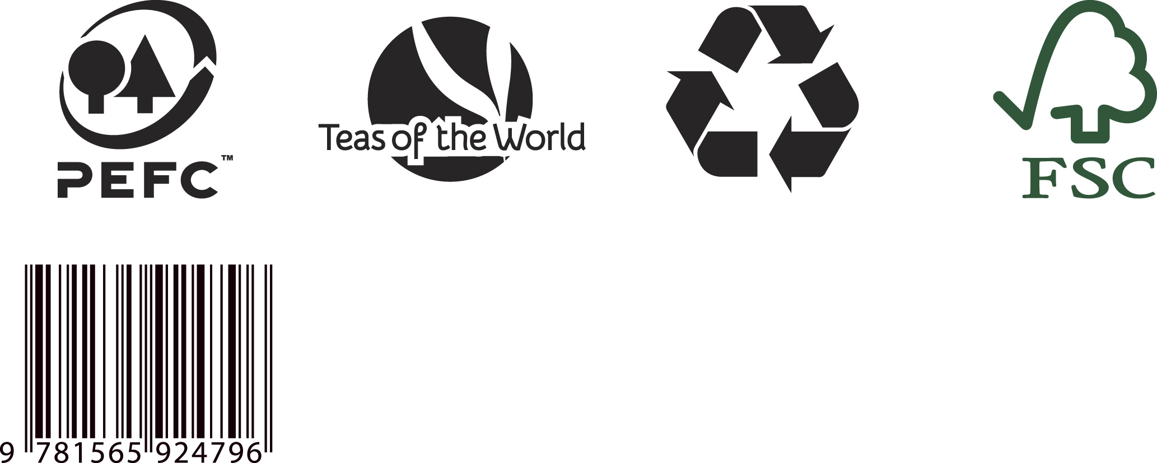
Appendix 2.3 / 附件2.3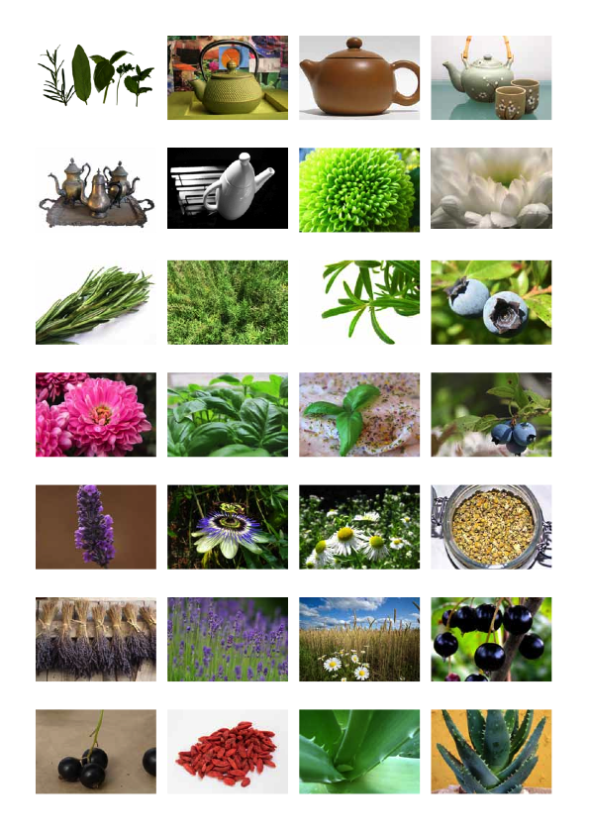

Appendix 2.3 (continued) / 附件2.3（承上一頁）

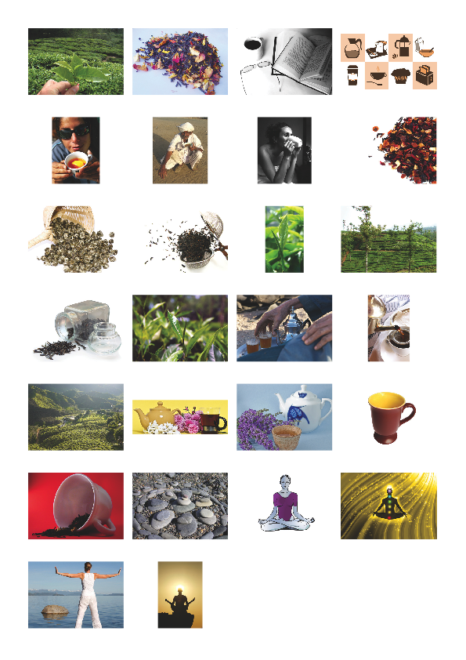
Appendix 3.1 / 附件3.1

Appendix_3.1.txt:

Label 1

Sensorial Tea Range: Teas to alter your body, mind and spirit

Meditation Tea
For calming and relaxing the body and mind
30g

標籤一

感知茶系列：改變你的身心靈的茶
沉思茶
鎮靜與放鬆身心靈
30克

Label 2

Sensorial Tea Range: Teas to alter your body, mind and spirit

Uplifting Tea
For happiness and energising the spirit
30g

標籤二

感知茶系列：改變你的身心靈的茶
愉悅茶
使精神愉悅充滿活力
30克

Label 3

Sensorial Tea Range: Teas to alter your body, mind and spirit

Concentration Tea
For concentration and mental vigour
30g

標籤三

感知茶系列：改變你的身心靈的茶
專注茶
專注與精神的活力
30克

